**Roselea Court Newsletter**

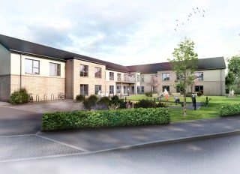

Latest news and bulletin updates

Welcome to the first edition of our Roselea Court Newsletter.

The aim of our newsletter is to share news, stories, poetry, anecdotes, and the list goes on.

We would welcome any comments or articles written by residents, relatives and friends and staff.

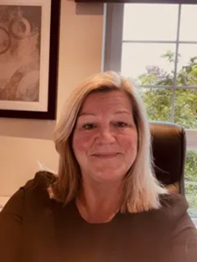

HELEN KINNARD

HOME MANAGER

Hi everyone,

So, we are settling in well now and continuing weekly, to admit new residents.

We will soon be looking at opening our last unit, it has been quick, considering we have not even been open to residents for 6 months yet. But it has also been great to see new residents moving in and settling in.

The residents are developing friendships and getting together to participate in our planned activity programs, offering suggestions to what would be good to have in the future.

We are continuing to recruit to support in our increasing occupancy. Recruiting into a care home is time consuming and we want to make sure we get the right staff. As we look ahead, we must understand how care changes daily and how easily it can be compromised. We want, and need, our staff to have and develop skills that allow them to care, underpinned by dignity, respect, humanity and equality.

I want a workforce that is not only satisfied by the care they provide, they need to be able to see the visible changes it makes to residents. You will know that's being achieved when you see smiles, hear laughter, witness a caring embrace. I hope you agree my sentiments.

Looking forward we are aiming to open up our 'Be Happy Cafe' through the summer and we hope you will join us for a coffee. If you would like to volunteer in the support of the cafe, to serve teas, then please let us know.

One of our key objectives is to maintain our visiting capabilities, we know that testing daily can sometimes feel tedious, however the health and well-being of the residents and our staff is a primary objective.

Our staff continue to LFT twice weekly and PCR weekly in line with Government guidelines.

We really want friends and family to share in our daily life within the care home, join in with activities.

We feel we are privileged to be supporting the residents in our care home.

I am sure that the continuing months ahead will bring some challenges, however, we will continue learning and developing to make Roselea Court a lovely and caring home for the residents who live in it.

That's all from me at the moment, but if you have any suggestions that you think would benefit the home, please let us know.

Thanks,

Helen.

Well Being Update

The Wellbeing Team like to keep you all updated with what’s going on in and around the home. We have new activities information boards in each unit which will give you details of the weekly activities, monthly special activities and also our upcoming planned events.

We had a very successful time in June for our Jubilee Week celebrations where our residents and relatives are still raving about the lovely time they had.

We are also going to be getting out and about more in our community by taking the residents to our local church St.Ninians Parish, out for lunch, cinema trips, pub trips.

|  |  |  |
| --- | --- | --- |
| Text, logo, company name  Description automatically generated  Salvation Army Service will be held on the last Sunday in the month in the Champagne Lounge where we will have a time of worship and prayer with our volunteers from the Salvation Army. | Text, whiteboard  Description automatically generated  Roselea Court will be hosting its very first Christmas Fayre on Saturday the 26th of November 2022  from  1:00pm – 4:00pm  We are looking for donations to help make this day a success. Please see the Wellbeing Team if you can help in any way. | A black and white logo  Description automatically generated with low confidence  We have started doing a fund raising sheet called a Joe 90. There are 90 numbers to chose from at a cost of £5. The winning number will win £200 and £250 will then go to the client fund and will pay for extra activities such as outings, entertainers. Please see the Wellbeing Team for your lucky number. |

|  |  |
| --- | --- |
| **Staff Profile  Andy Veitch**  Andy brings a wealth of experience having worked in various demolition, recycling plant set ups where building and ongoing maintenance has been key.  Andy is a key member of the team at Roselea Court and looks after the maintenance and DIY of the home ensuring that it has a beautiful, homely feel for you to enjoy, while you are residing here. | **Maintenance Update**  The garden is getting well maintained for the upcoming summer months. We have lots of new patio furniture for you to enjoy when you are visiting your loved ones. We also ask if you could donate any plants, bushes or outdoor ornaments to make our gardens look wonderful for our residents and relatives to enjoy.  The care home is well maintained to a high standard and if you see anything that needs fixed or have any maintenance issues, please advise me or any member of staff so we can keep the home in pristine condition. |

|  |  |
| --- | --- |
|   **Housekeeping**  The department is fully staffed, and Head Housekeeper Nancy welcomes any feedback from relatives or residents.  **Laundry**  Laundry is still being washed at 65 degrees for infection control and laundry team have advised that anything that cannot be washed at this temperature should be taken home and suggested that relatives provide a small washing basket for these items so this helps staff putting it down to laundry by mistake. Buttons are provided for all room numbers to identify laundry and any new items being brought in should be buttoned to prevent the loss of items. please hand to laundry staff with resident’s name and room number on so this system can be most effective. | **Hospitality update**  The Hospitality Team have produced new menus which will be put in place this month.  Our residents and relatives are also encouraged to give feedback at any time not just at planned meetings. The kitchen staff would be happy to hear your comments.  Comments from the residents and relatives meeting were all positive and residents were overwhelmed by the food they received at the Jubilee celebrations with their picnic, BBQ, and fish & chips all served to at such high standard.  Residents gave positive feedback on the meals being served with comments “that the food was remarkable” and “The new menu looked much improved”. There were also suggestions that some of our residents would like an around the world theme menu, cheese souffles and pizzas be added occasionally. |



The Bee Happy Café is now open

on a

Monday and Wednesday

from 2:00pm – 4:00pm.

We have a lovely new volunteer.

Natalie will whip you up a delightful

Drink and our wonderful chefs have

Provided their splendid range of

sweet treats to go with your drink.

All we ask is a donation to cover

our costs.

Thank you

We would like to introduce our café volunteer Natalie.

Natalie is the finest coffee maker around and will bee happy to serve you your hot drinks at the café.

Please pop in and say hello to Natalie



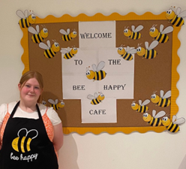

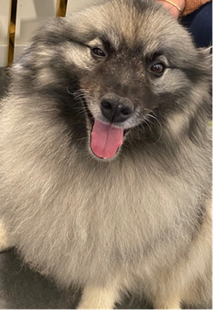We would like to introduce you to our beautiful pet therapy dog Tara

who will be visiting us every second Monday with her mum and owner Shirley. Spending time with our pet therapy dog (Tara) has been known to offer several mental, physical and emotional benefits, which can improve your quality of life. Animal assisted therapy such as dog pet therapy can significantly reduce fatigue, anxiety and depression including a range of different health problems.



**We would like to wish all our residents and staff a very happy birthday for the month of August.**

**Happy Birthday**



We have introduced monthly photo books to capture the fun that our residents are having while doing their daily activities. These will be in the front reception and are for all to have a look at when visiting their loved ones.